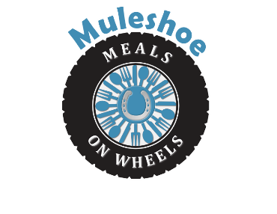 | Bailey County Office of Aging  300 S 1st St., #110  Muleshoe, TX 79347  806-272-3647
MULESHOE MEALS ON WHEELS, INC.
QUALIFICATIONS
Revised (1/17/2023)
The purpose of MULESHOE MEALS ON WHEELS, INC. is to promote and further the interests of the Senior citizens of Muleshoe with particular emphasis on serving home delivered meals to qualified subscribers as needs may arise, and as financial and other conditions may permit without regard to race, creed, color, sex or national origin, and without respect to financial or social status.
The County hereby certifies that the Organization provides home-delivered meals to homebound persons in the City of Muleshoe who are elderly and/or have a disability.
Qualifications to meet are as follows:
- Must live within the city limits of Muleshoe, Texas
- Must be age 60 or older or disabled and has need of a home delivered meal.
- Muleshoe Meals on Wheels will at a doctor’s request provide temporary meals to those recovering from an accident, surgery or severe illness where there is no one in the home to take on the role of caregiver. Clients under the age of 60 must provide a copy of their SSI award letter or have a signed document from their health care provider of which will be verified.
- Persons applying for Muleshoe Meals on Wheels must fill out and sign the Intake and Assessment forms. In the event of false information being provided on these forms, it will result in the termination of your meals. All Intakes must be renewed yearly.
Muleshoe Meals on Wheels is here to serve the elderly/disabled in our community. We are a non-profit organization requiring strict diligence with all funds. The cost of each meal is $4.00 a day. If you would like to donate towards your meals, please make your check payable to Muleshoe Meals on Wheels and mail to 300 S 1st St., #110, Muleshoe, TX 79347

